How can I sensibly assign weights to embeddings to make them more accurate?

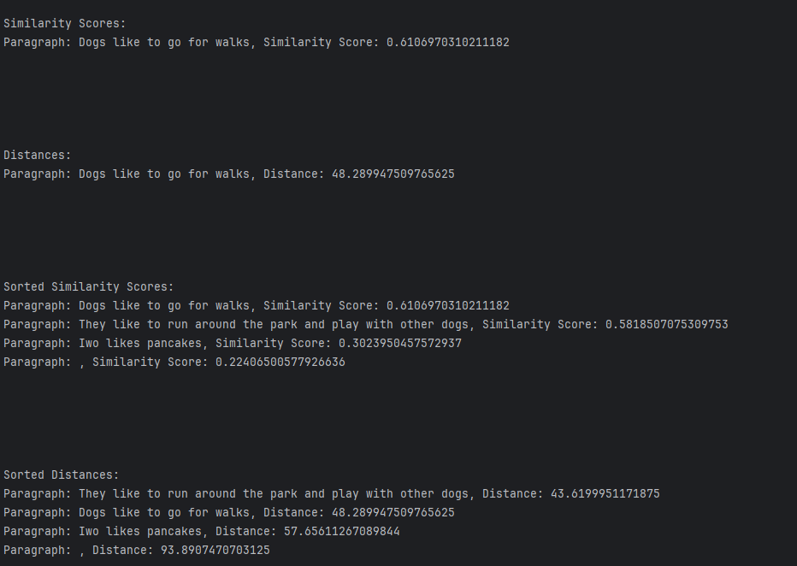

At the same time, I am not sure whether the cosine similarity result is acceptable and accurate

document = """  
Dogs like to go for walks. They like to run around the park and play with other dogs. Iwo likes pancakes.  
"""

query = "What dog like do?"

tokenizer = AutoTokenizer.from_pretrained("dunzhang/stella_en_1.5B_v5", trust_remote_code=True)  
model = AutoModelForCausalLM.from_pretrained("dunzhang/stella_en_1.5B_v5", trust_remote_code=True).to(device)